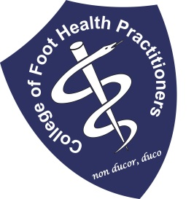THE COLLEGE OF FOOT HEALTH PRACTITIONERS

CLINICAL TRAINING DAYS in 2024
FOOT HEALTH PRACTITIONERS COURSE

January 15TH – 26th
February 12th to 23th
March 11th to 22th
April 8th to 19th
May 13th to 24th
June 10th to 21st
July 15th to 26th
August 12th to 23rd
September 9th to 20th
October 7th to 18th
November 11th to 22nd
December 2nd to 13th

EXCLUDING WEEKENDS

RESERVE YOUR PLACE PLEASE CONTACT:
Phone: 0121 559 0180
See our web site: www.collegefhp.com
Doc: OPDY
Version 6
Date: Nov ‘20

Dat

